Tutorial 3: Lasers

In this tutorial I will show you how to create lasers that destroy the player and are animated back and forth, with a 1 second break when they reach point A then another break when they reach point B.

1. Firstly, create an empty game object called LaserParent then create a cylinder object, resize it to a small laser shape, and make that a child of LaserParent - call the cylinder Laser
2. Next, create a new material and call it LaserMaterial, make it a deep red colour and put the metallic value to 1 while putting the smoothness to 0. Also change the rendering mode to transparent and once the material is done apply it to the Laser.
3. Next, we will create the animation for the laser to go back and forth. Give the LaserParent an animator component and then go on to the Animation tab and click create, call the animation something like LaserMove. Then click add property and select the Laser to transform from the list NOT the LaserParent. Select the keyframes at 1 second and move them to 2 seconds, click on one second and insert a new keyframe then hit the record button and move the laser to where you want it to move to before it moves back to its original position and de-select record.
4. 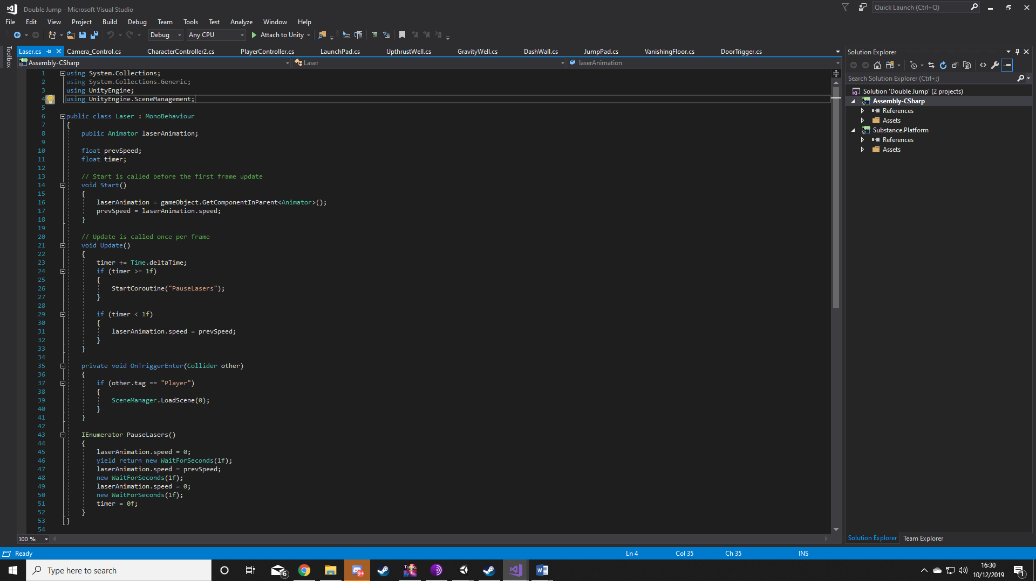Next, add a capsule collider to the Laser, make it a trigger, and then create a new script to go on it and call it LaserAnimation. Create the variables you see in the picture (Also call Unity.SceneManagement; at the top) and then in the start method type laserAnimation = gameObject.GetComponentInParent<Animator>(); which will create a reference to the animator component on the LaserParent. Then type prevSpeed = laserAnimation.speed; which sets the prevSpeed variable to the Animators animation speed at the start which is 1.
5. Next, in the Update method type timer += Time.deltaTime; which will count the timer up in seconds. Then create an IF statement that says timer >= 1f and in that IF statement type StartCoroutine(“PauseLasers”); this means that if the timer is greater than 1 second then it will start the Coroutine. Create another IF statement that says IF timer < 1f then in that statement type laserAnimation.speed = prevSpeed; this means if the timer is less than one second the Animators speed is set to prevSpeed which is 1, this stops the animation getting stuck and makes sure the whole script loops round properly.
6. Next, create a new OnTriggerEnter(Collider other) and inside create and IF statement that says other.tag == “Player” and in the IF statement type SceneManager.LoadScene(0); this means that if the player touches the collider of the cylinder then it will reload the scene indicating death. Don’t forget to create a tag called Player and apply it to the player
7. Finally, create a new IEnumerator called PauseLasers() and inside the method type laserAnimation.speed = 0; then yield return new WaitForSeconds(1f); then laserAnimation.speed = prevSpeed; then new WaitForSeconds(1f); then laserAnimation.speed = 0; then new WaitForSeconds(1f); then finally timer = 0; First the animation speed is set to 0 which essentially pauses the animation to keep the lasers in place, then there is a break for 1 second before setting the speed back to 1. This resumes the animation and then there is another second before it is paused again and after another second the timer is reset to 0, effectively restarting the whole script so the animation doesn’t get stuck.
8. 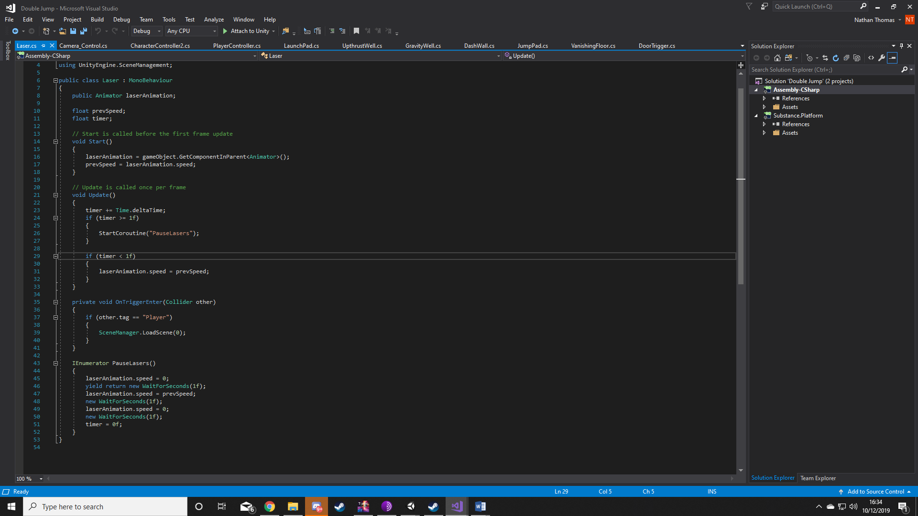Once everything is done and you have your laser you can turn it into a prefab and you can place multiple of them wherever you want.